# # Basic HTML Structure

The basic structure of an HTML document consists of nested elements that define the content and layout of a webpage. It starts with <!DOCTYPE html>, followed by <html>, which contains the <head> for metadata and <body> for visible content.

<!DOCTYPE html>

<html>

<head>

<title>Page Title</title>

</head>

<body>

<h1>Main Heading</h1>

<p>This is a paragraph.</p>

</body>

</html>

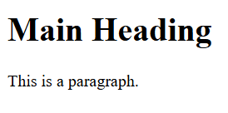

# # Headings & Paragraphs

Headings in HTML (<h1> to <h6>) define the titles and subtitles of content, with <h1> being the most important and <h6> the least. Paragraphs are defined using the <p> tag and are used to group sentences or blocks of text into readable sections.

<h1>content</h1>

<h6>content</h6>

<p>content</p>

<!DOCTYPE html>

<html>

<head>

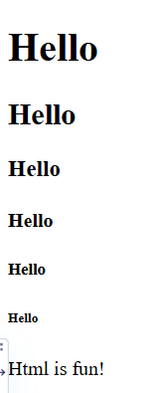

<title>HTML Headings</title>

</head>

<body>

<h1>Hello</h1>

<h2>Hello</h2>

<h3>Hello</h3>

<h4>Hello </h4>

<h5>Hello </h5>

<h6>Hello </h6>

<p>Html is fun!</p>

</body>

</html>

# #Display, Preformatted

Text, Horizontal Rules, Line Breaks

1. Display (using HTML tags)

HTML elements like <div>, <span>, and others are used to control how content is displayed. They don’t format content themselves but structure it for styling and layout.

<div>content</div>

<span>content</span>

1. Preformatted Text

The <pre> tag displays text exactly as written in the HTML (including spaces, tabs, and line breaks).

<pre>content</pre>

1. Horizontal Rule

The <hr> tag creates a horizontal line across the page, used to separate content. It's a self-closing tag.

<hr>

1. Line Break (<br>)

The <br> tag inserts a single line break, useful for breaking lines without starting a new paragraph.

<br>

<!DOCTYPE html>

<html>

<head>

<title>HTML Elements Example</title>

</head>

<body>

<div>Div: This is a block-level element </div>

<span>Span: This is an inline element </span>

<hr>

<h2>Preformatted Text Example:</h2>

<pre>

#include &ltstdio.h&gt int main(){ printf("hello");

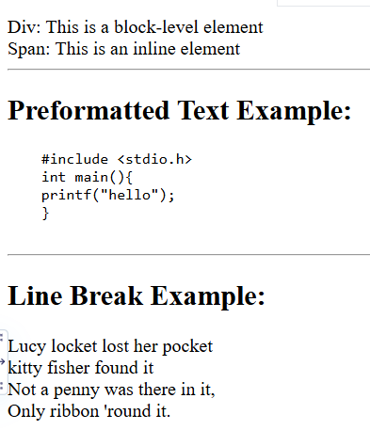

}

</pre>

<hr>

<h2>Line Break Example:</h2>

<p>Lucy locket lost her pocket<br>kitty fisher found it<br>Not a penny was there in it,<br>Only ribbon 'round it. </p>

</body>

</html>

#Text Formatting

1. Bold (Non-semantic)
   * Makes text bold, used only for visual styling without importance.

<b>content</b>

1. Strong (Importance)
   * Makes text bold and signals **important content**.

<strong>content</strong>

1. Italic (Non-semantic)
   * Displays text in italics for stylistic purposes.

<i>content</i>

1. Emphasized Text
   * Italicizes text **and** gives it emphasis.

<em>content</em>

1. Highlighted Text
   * Highlights or marks text with a yellow background (by default).

<mark>content</mark>

1. Deleted Text
   * Displays text with a strikethrough, showing it has been removed.

<del>content</del>

1. Inserted Text
   * Underlines the text to show it was **newly added**.

<ins>content</ins>

1. Subscript
   * Lowers text slightly below the line, like chemical formulas.

<sub>content</sub>

1. <sup> – Superscript
   * Raises text slightly above the line, like exponents or footnotes.

<sup>content</sup>

<!DOCTYPE html>

<html>

<head>

<title>Text Formatting Example</title>

</head>

<body>

<h2>Text Formatting in HTML</h2>

<p><b>Bold:</b> The <b>sun</b> is a star at the center of our

solar system.</p>

<p><strong>Strong:</strong> <strong>Warning!</strong> Do not touch live wires.</p>

<p><i>Italic:</i> The word <i>cliché</i> is often overused in writing.</p>

<p><em>Emphasized:</em> You <em>must</em> submit the

form before the deadline.</p>

<p><mark>Marked:</mark> Your score of <mark>95%</mark> is outstanding!</p>

<p><del>Deleted:</del> This product is <del>no longer available</del>.</p>

<p><ins>Inserted:</ins> Please note the <ins>new class timings</ins>.</p>

<p><sub>Subscript:</sub> The chemical formula of water is

H<sub>2</sub>O.</p>

<p><sup>Superscript:</sup> The equation is E = mc<sup>2</sup>.</p>

</body>

</html>

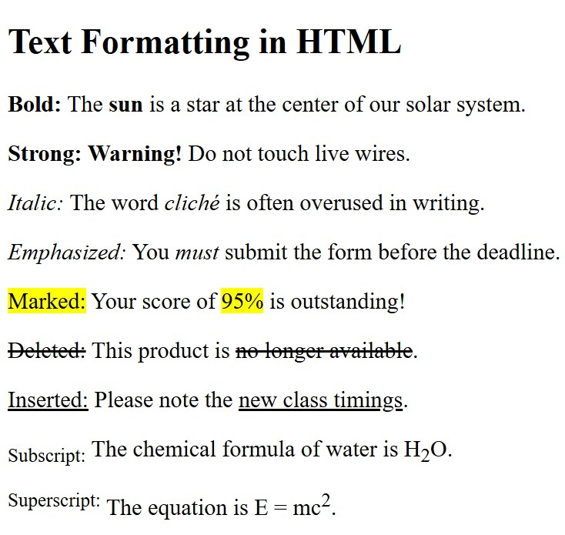

### #Quotation & Citation Elements

1. Block Quotation
   * Used for **long quotations** from an external source.

<blockquotate cite=””>content</blockquote>

1. Short Inline Quotation
   * Used for **short, inline quotations**. Automatically adds quotation marks.

<q>content</q>

1. Citation or Source Title
   * Represents the **title of a creative work** (book, website, movie, etc.)

<cite>content</cite>

1. Abbreviation or Acronym
   * Shows the full form when hovered (via the title attribute).

<abbr tittle=””>content</abbr>

1. Contact Information
   * Used to display contact info of the author/owner of a document or article.

<address>content</address>

1. Bi-Directional Override
   * The <bdo> tag is used to **override the default text direction** for content.

<bdo dir=”rtl”>content</bdo>

<!DOCTYPE html>

<html>

<head>

<title>Hope for All - NGO</title>

</head>

<body>

<h1>Hope for All</h1>

<p><abbr title="Non-Governmental Organization">NGO</abbr>

dedicated to education and healthcare in rural areas.</p>

<hr>

<blockquote cite="https://hopeforall.org/stories">

"Thanks to Hope for All, I can now read, write, and dream of becoming a teacher someday."

</blockquote>

<p>— <cite>Asha, Student from Village Aid Program</cite></p>

<hr>

<p>

Our mission is to bring lasting change to underprivileged communities.

<small>Registered under the Societies Registration Act, 1860</small>

</p>

<hr>

<address>

Hope for All Foundation<br>

456 Charity Lane, Green City, India<br>

<a

href[="mailto:contact@hopeforall.org">contact@hopeforall.org<](mailto:contact@hopeforall.org)/a><br

>

Website: <a href="https[://www.hopeforall.org">www.hopeforall.org<](http://www.hopeforall.org/)/a>

</address>

<hr>

<p>Message in normal direction: Hope unites us all.</p>

<p>Message in right-to-left: <bdo dir="rtl">Hope unites us all.</bdo></p>

</body>

</html>

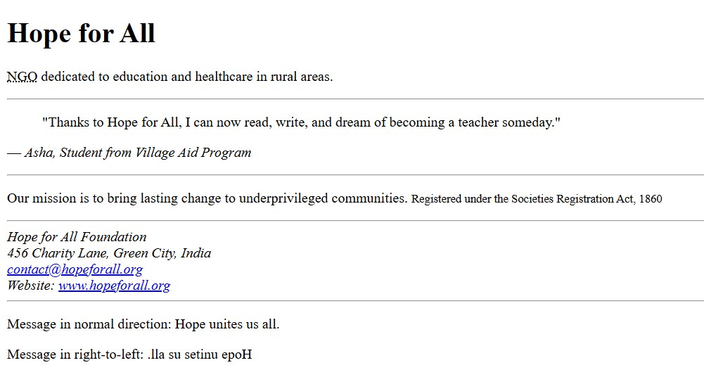

### #Comments

**Comments** in HTML are used to leave notes or explanations in the code. They are **not displayed** in the browser.

<!-- content -->

<!DOCTYPE html>

<html>

<head>

<title>Smartphone Details</title> <!-- Title shown in browser tab -->

</head>

<body>

<!-- Heading about the product -->

<h1>Samsung Galaxy S25</h1>

<!-- Short description paragraph -->

<p>The Samsung Galaxy S25 features a powerful processor.</p>

</body>

</html>

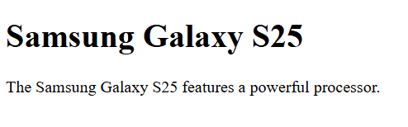

# #Links and Hyperlinks

Links or **hyperlinks** in HTML are created using the <a> tag, allowing users to **navigate to other web pages, sections, or files**. The destination is set using the href (hypertext reference) attribute.

<a href=””>content</a>

<!DOCTYPE html>

<html>

<head>

<title>Link vs Hyperlink Example</title>

</head>

<body>

<h1>Link vs Hyperlink in HTML</h1>

<p>This is a plain text link: http[s://www.example.com</](http://www.example.com/)p>

<p>This is a clickable hyperlink: <a href="https[://www.example.com">Visi](http://www.example.com/)t Example</a></p>

</body>

</html>

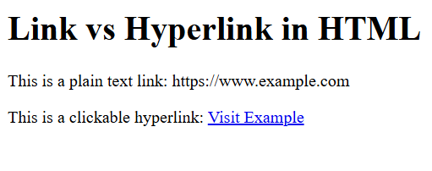

# #Image

In HTML, images are inserted using the <img> tag. It is a **self-closing tag** that requires the src (source) and alt (alternative text) attributes.

<img src="image.jpg" alt="Description of image">

<!DOCTYPE html>

<html>

<head>

<title>Image Example</title>

</head>

<body>

<h1>Canada</h1>

<img src="https://tse3.mm.bing.net/th/id/OIP.nJ3J0Cbb89lmVy4ysIEFYQHaE 5?pid=Api&P=0&h=180" alt="Canada flag" width="300" height="200">

<p>The flag of Canada features a red maple leaf in the center, with red bars on both sides.</p>

</body>

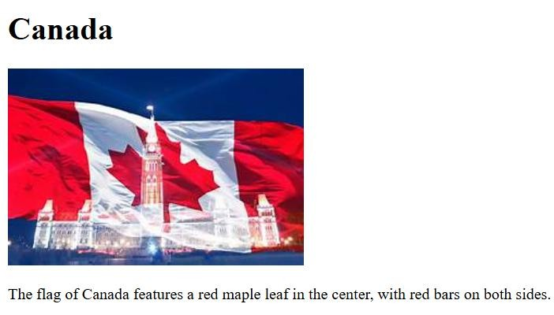

</html>

# #Lists

HTML lists are used to group related items. There are **three main types**

of lists:

* **Ordered list (<ol>)** – numbered
* **Unordered list (<ul>)** – bulleted
* **Description list (<dl>)** – terms and descriptions

|  |  |  |
| --- | --- | --- |
| <ol> | <ul> | <dl> |
| <li>content</li> | <li>content</li> | <li>content</li> |
| </ol> | </ul> | </dl> |

<!DOCTYPE html>

<html>

<head>

<title>Daily Routine</title>

</head>

<body>

<h1>My Daily Routine</h1>

<h2>Morning Routine</h2>

<ul>

<li>Wake up and stretch</li>

<li>Drink a glass of water</li>

<li>Morning meditation (10 minutes)</li>

<li>Have a healthy breakfast</li>

<li>Get dressed for the day</li>

</ul>

<h2>Evening Routine</h2>

<ol>

<li>Prepare and eat dinner</li>

<li>Go for a walk or light exercise</li>

<li>Read a book or journal</li>

<li>Unplug from devices 1 hour before bed</li>

<li>Practice relaxation or light stretching</li>

<li>Go to bed by 10:30 PM</li>

</ol>

<h2>Additional Notes</h2>

<dl>

<dt>Tips for better sleep</dt>

<dd>Avoid caffeine after 3 PM and keep your bedroom dark and cool.</dd>

<dt>Hydration reminder</dt>

<dd>Drink at least 8 glasses of water throughout the day.</dd>

<dt>Mental health</dt>

<dd>Take breaks during work to reduce stress and maintain focus.</dd>

</dl>

</body>

</html>

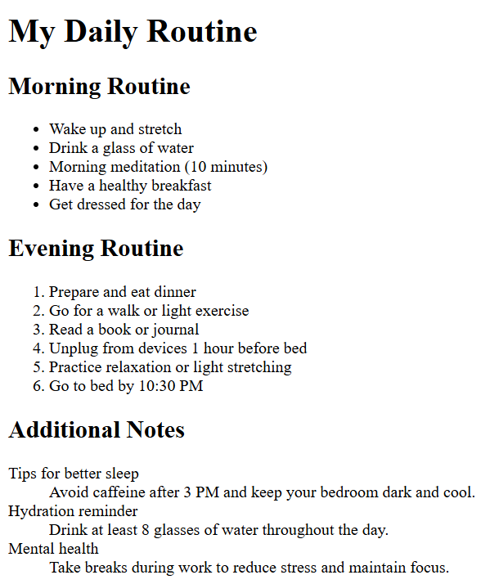

# #Tables

Tables are used to display **tabular data** in rows and columns. They are great for organizing information like schedules, pricing, comparison charts, or any data grid.

<table>

<tr>

<th>Header 1</th>

</tr>

<tr>

<td>Data 1</td>

</tr>

</table>

<!DOCTYPE html>

<html>

<head>

<title>Simple Table Example</title>

</head>

<body>

<h2>Student Scores</h2>

<table border="1" cellpadding="8">

<tr>

<th>Name</th>

<th>Score</th>

</tr>

<tr>

<td>kavya</td>

<td>85</td>

</tr>

<tr>

<td>Bob</td>

<td>92</td>

</tr>

</table>

</body>

</html>

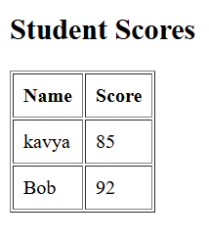

### #Colspan & Rowspan Table

An **HTML table** is used to display data in a **grid format** of **rows and columns**. It’s useful for organizing structured information such as timetables, scoreboards, and product comparisons.

<td colspan="2">Merged Cell</td>

<td rowspan="2">Merged Cell</td>

<!DOCTYPE html>

<html lang="en">

<head>

<meta charset="UTF-8">

<title>Colspan and Rowspan Table</title>

</head>

<body>

<h2>Colspan and Rowspan Example Table</h2>

<table border="1" cellpadding="8" cellspacing="0">

<tr>

<th>Day</th>

<th colspan="2">Morning Activities</th>

<th>Evening</th>

</tr>

<tr>

<td rowspan="2">Monday</td>

<td>Yoga</td>

<td>Breakfast</td>

<td rowspan="2">Reading</td>

</tr>

<tr>

<td>Work</td>

<td>Lunch</td>

</tr>

<tr>

<td>Tuesday</td>

<td colspan="2">Work from home</td>

<td>Gym</td>

</tr>

<tr>

<td>Wednesday</td>

<td>Jogging</td>

<td colspan="2">Office Meeting</td>

</tr>

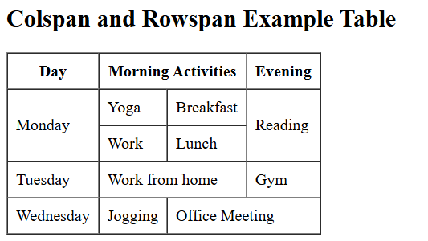

</table>

</body>

</html>

# #Character Entities

**HTML character entities** are special codes used to display reserved or non-keyboard characters (like <, >, ©, etc.) in web pages.

&#entity_number;

<!DOCTYPE html>

<html lang="en">

<head>

<meta charset="UTF-8">

<title>Character Entities Example</title>

</head>

<body>

<h2>Using Character Entities</h2>

<p>This is how you write HTML tags: &lt;html&gt; ... &lt;/html&gt;</p>

<p>5 &gt; 3 and 3 &lt; 5</p>

<p>Use &amp; to represent an ampersand (&)</p>

<p>Copyright: &copy; 2025</p>

<p>Registered Trademark: &reg;</p>

<p>Euro Symbol: &euro;</p>

<p>Indian Rupee Symbol: &#8377;</p>

<p>Smiley Emoji: &#128522;</p>

</body>

</html>

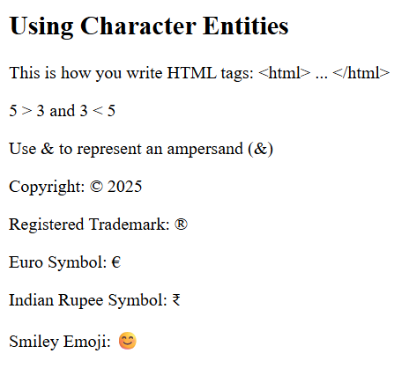

### #Block & Inline Elements

Block elements **start on a new line** and take up the **full width** of their parent container.

Inline elements **do not start on a new line**.They only take up as much

**width as necessary**, and sit **within** block elements

<elementname>Content goes here</elementname>

<elementname>Inline content</elementname>

<!DOCTYPE html>

<html>

<head>

<title>Office Employee Card</title>

</head>

<body>

<div>

<h2>Employee Profile</h2> <!-- Block element -->

<p><strong>Name:</strong> John Doe</p> <!-- Inline inside block --

>

<p><strong>Position:</strong> Senior Developer</p>

<p><strong>Email:</strong> <a

href[="mailto:john.doe@example.com">john.doe@example.com</a>](mailto:john.doe@example.com)</ p>

<p>

<strong>Skills:</strong>

<span>HTML</span>,

<span>CSS</span>,

<span>JavaScript</span>

</p>

</div>

</body>

</html>

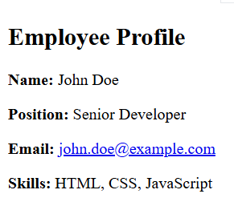

# #Forms

**Forms** are used in HTML to collect user input and send it to a server or process it on the client side. They are essential for things like login pages, surveys, contact forms, and registrations.

<form action="submit_url" method="post">

<label>Name:</label>

<input type="text" name="username" />

<input type="submit" value="Submit" />

</form>

<!DOCTYPE html>

<html lang="en">

<head>

<title>Contact Form</title>

</head>

<body>

<h2>Contact Us</h2>

<form action="/submit-form" method="post">

<label for="fullname">Full Name:</label><br />

<input type="text" id="fullname" name="fullname" required />

<label for="email">Email:</label><br />

<input type="email" id="email" name="email" required />

<label for="message">Message:</label><br />

<textarea id="message" name="message" rows="5" cols="30" required></textarea>

<input type="submit" value="Send Message" />

</form>

</body>

</html>

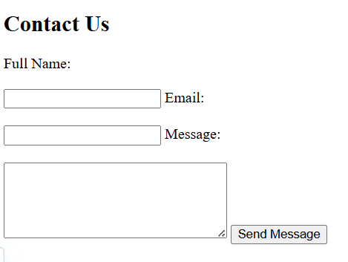

### #input attributes

<input> attributes define the behavior and appearance of input fields in HTML forms. They control the input type, validation rules, and user interaction.

<input type="text" name="username" placeholder="Enter your name" required>

<!DOCTYPE html>

<html>

<head>

<title>Input Attributes Example</title>

</head>

<body>

<h2>User Registration</h2>

<form action="/submit" method="post">

<label for="username">Username:</label><br />

<input type="text" id="username" name="username" placeholder="Enter username" required maxlength="15" />

<label for="email">Email:</label><br />

<input type="email" id="email" name="email" placeholder="Enter email" required />

<label for="age">Age:</label><br />

<input type="number" id="age" name="age" min="18" max="99" />

<input type="submit" value="Register" />

</form>

</body>

</html>

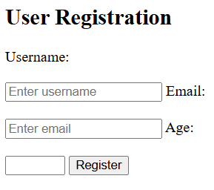

# #Submit & Button

<input type="submit"> creates a button that submits the form when clicked.

<button> it can submit, reset, or perform other actions and can contain HTML content

<input type="submit" value="Submit" />

<button type="submit">Submit</button>.

<!DOCTYPE html>

<html>

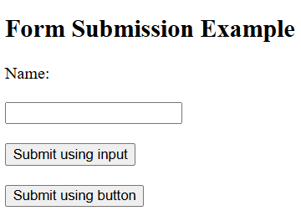

<head>

<title>Submit & Button Example</title>

</head>

<body>

<h2>Form Submission Example</h2>

<form action="/submit" method="post">

<label for="name">Name:</label><br />

<input type="text" id="name" name="name" required /><br />

<input type="submit" value="Submit using input" /><br />

<button type="submit">Submit using button</button><br />

</form>

</body>

</html>

<!DOCTYPE html>

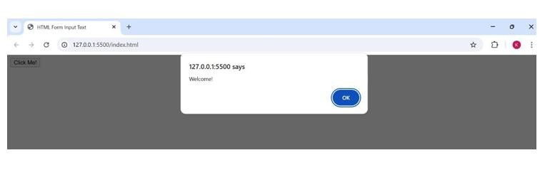

<html>

<head>

<title>HTML Form Input Text</title>

</head>

<body>

<form>

<input type="button" value="Click Me!" onclick="alert('Welcome!')">

</form>

</body>

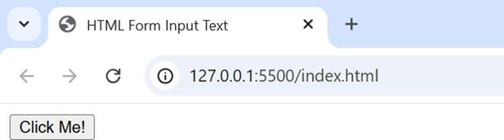

</html>

# #Input Image

* It creates an **image button** inside a form. Clicking the image submits the form.

<input type="image" src="image_url" alt="Submit" width="100" height="50" />

<!DOCTYPE html>

<html>

<head>

<title>HTML Form Input Image</title>

</head>

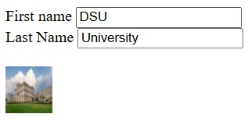

<body>

<form action=" ">

<label for="fname">First name</label>

<input type="text" id="fname" name="fname" value="DSU"><br>

<label for="lname">Last Name</label>

<input type="text" id="lname" name="lname" value="University"><br><br>

<input type="image" src="https://tse4.mm.bing.net/th/id/OIP.pY5aacbfgRV7B9hwrfN46QHa Ec?pid=Api&P=0&h=180" alt="Submit" width="48" height="48">

</form>

</body>

</html>

# #Input Password

It creates a **password field** where the user can enter sensitive information.

<input type="password" name="password" placeholder="Enter your password" required />

<!DOCTYPE html>

<html>

<head>

<title>HTML Input Password</title>

</head>

<body>

<form>

<label for="username">Username</label><br>

<input type="text" id="username" name="username"><br>

<label for="pwd">Password</label><br>

<input type="password" id="pwd" name="pwd"><br>

</form>

</body>

</html>

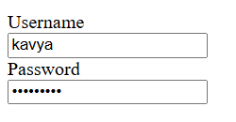

# #Input Email

It creates an input field specifically for **email addresses**.

<input type="email" name="email" placeholder="Enter your email" required />

<!DOCTYPE html>

<html lang="en">

<head>

<title>Email Input Example</title>

</head>

<body>

<h2>Subscribe to Newsletter</h2>

<form action="/subscribe" method="post">

<label for="email">Email Address:</label><br />

<input type="email" id="email" name="email" placeholder="Enter your email" required /><br />

<input type="submit" value="Subscribe" />

</form>

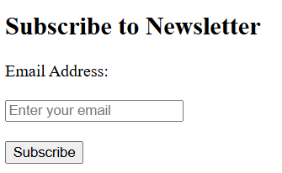

</body>

</html>

# #Textarea

* <textarea> is used when you need a multi-line text input field.

<textarea name="yourname" rows="4" cols="50">Default text</textarea>

<!DOCTYPE html>

<html>

<head>

<title>HTML Textarea Element</title>

</head>

<body>

<form>

<label for="comment">Comments:</label>

<textarea id="comment" name="comment"> HTML is fun to learn.

</textarea>

<input type="submit">

</form>

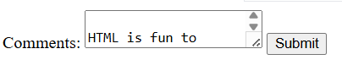

</body>

</html>

# #Radio and Checkbox

**Radio buttons** allow users to select **only one option** from a group.

**Checkboxes** let users select **one or more options**

independently.

<input type="radio" name="gender" value="male"> Male

<input type="checkbox" name="hobby" value="reading"> Reading

<!DOCTYPE html>

<html lang="en">

<head>

<title>Radio and Checkbox Example</title>

</head>

<body>

<h2>User Preference Form</h2>

<form action="/submit" method="post">

<p><strong>Select Gender:</strong></p>

<input type="radio" id="male" name="gender" value="male">

<label for="male">Male</label><br>

<input type="radio" id="female" name="gender" value="female">

<label for="female">Female</label><br>

<p><strong>Select Your Hobbies:</strong></p>

<input type="checkbox" id="reading" name="hobby" value="Reading">

<label for="reading">Reading</label><br>

<input type="checkbox" id="music" name="hobby" value="Music">

<label for="music">Music</label><br>

<input type="submit" value="Submit">

</form>

</body>

</html>

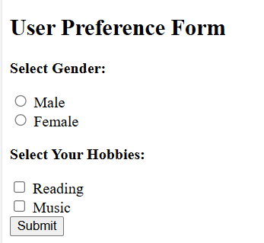

### #Input File, Date

Allows the user to **upload a file** from their device.

<input type="file" name="uploadfile" />

<!DOCTYPE html>

<html>

<head>

<title>HTML Form Input Text</title>

</head>

<body>

<form>

<label for="files">Select files: </label>

<input type="file" id="files" name="files" multiple>

</form>

</body>

</html>



### #Select Element (Dropdowns)

* The <select> element creates a **dropdown list** in HTML forms.

<select name="dropdown-name">

<option value="option1">Option 1</option>

<option value="option2">Option 2</option>

</select>

<!DOCTYPE html>

<html>

<head>

<title>HTML Select Element</title>

</head>

<body>

<form>

<label for="states">Select a state: </label>

<select id="states" name="states" size="3">

<option value="AP">Andhra Pradesh</option>

<option value="BR">Bihar</option>

<option value="CH">Chhattisgarh</option>

<option value="HP">Himachal Pradesh</option>

<option value="KA" selected>Karnataka</option>

<option value="MH">Maharashtra</option>

<option value="TN">Tamil Nadu</option>

</select>

<input type="submit">

</form>

</body>

</html>

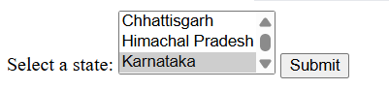

# #Reset Button

The <input type="reset"> button **clears all form fields**

and resets them to their default values.

<input type="reset" value="Reset Form">

<!DOCTYPE html>

<html>

<head>

<title>HTML Form Input Submit</title>

</head>

<body>

<form action=" ">

<label for="fname">First name</label><br>

<input type="text" id="fname" name="fname" value="DSU"><br>

<label for="lname">Last Name</label><br>

<input type="text" id="lname" name="lname" value="University"><br><br>

<input type="submit" value="Submit">

<input type="reset" value="Reset">

</form>

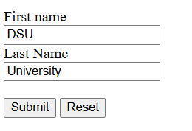

</body>

</html>

# #Form Action & Method

The action attribute in a form defines **where** the form data is sent.

The method attribute defines **how** the data is sent — commonly using GET or POST.

<form action="submit.php" method="post">

<!-- form elements -->

</form>

<!DOCTYPE html>

<html>

<head>

<title>HTML Form</title>

</head>

<body>

<form action="https://google.com">

<label for="fname">First name</label><br>

<input type="text" id="fname" name="fname" value="DSU"><br>

<label for="lname">Last Name</label><br>

<input type="text" id="lname" name="lname" value="University'"><br><br>

<input type="submit" value="Submit">

</form>

</body>

</html>

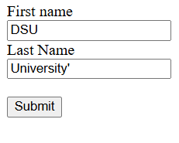

# #Novalidate Attribute

The novalidate attribute on a <form> disables the browser’s built-in **form validation** when submitting.

<form action="/submit" method="post" novalidate>

<!-- form elements -->

</form>

<!DOCTYPE html>

<html>

<head>

<title>HTML Form Input Text</title>

</head>

<body>

<form novalidate>

<label for="username">Username: </label>

<input type="text" id="username" name="username" required>

<input type="submit" value="Submit">

</form>

</body>

</html>



# #Audio & Video

The <audio> element embeds sound files with playback controls, while <video> embeds videos with controls like play and pause. Both support multiple sources and fallback text for unsupported browsers.

<audio controls>

<source src="audiofile.mp3" type="audio/mpeg"> Your browser does not support the audio element.

</audio>

<video controls width="320" height="240">

<source src="videofile.mp4" type="video/mp4"> Your browser does not support the video element.

</video>

<!DOCTYPE html>

<html lang="en">

<head>

<title>Audio & Video Example</title>

</head>

<body>

<h2>Audio Example</h2>

<audio controls>

<source

src="https[://www.soundhelix.com/examples/mp3/SoundHelix-Song-](http://www.soundhelix.com/examples/mp3/SoundHelix-Song-)

1.mp3" type="audio/mpeg" />

</audio>

<h2>Video Example</h2>

<video controls width="320" height="240">

<source src="https://interactive- examples.mdn.mozilla.net/media/cc0-videos/flower.webm" type="video/webm" />

</video>

</body>

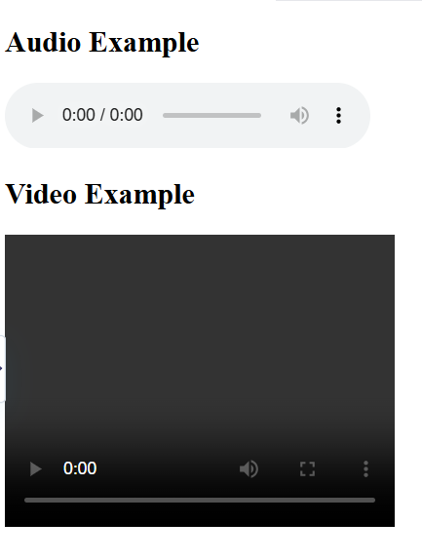

</html>

# #BASIC SCENARIOS

1. **Create a Simple Webpage** Build a basic HTML page with headings, paragraphs, and links.

<!DOCTYPE html>

<html lang="en">

<head>

<meta charset="UTF-8">

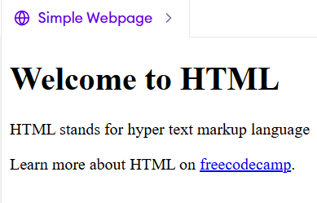

<title>Simple Webpage</title>

</head>

<body>

<h1>Welcome to HTML</h1>

<p>HTML stands for Hyper text markup language </p>

<p>Learn more about HTML on

<a href="https[://www.freecodecamp.org/learn/full-stack-](http://www.freecodecamp.org/learn/full-stack-) developer/">freecodecamp</a>.

</p>

</body>

</html>

1. **Personal Portfolio Page** Create a portfolio with name, bio, skills (unordered list), and project links.

<!DOCTYPE html>

<html lang="en">

<head>

<meta charset="UTF-8">

<title>My Portfolio</title>

</head>

<body>

<h1>Kavyashree Visaji</h1>

<p>Hello! I’m Kavyashree, a web developer passionate about coding.</p>

<h2>Skills</h2>

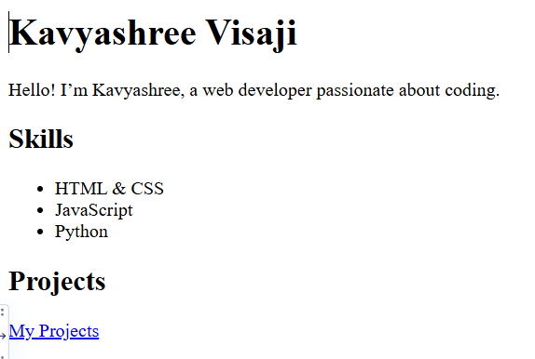

<ul>

<li>HTML & CSS</li>

<li>JavaScript</li>

<li>Python</li>

</ul>

<h2>Projects</h2>

<a href="https://github.com/kavyashree-visaji02">My Projects</a>

</body>

</html>

1. **Add Images and Captions** Insert images with <img> tags and add captions using <figcaption> inside <figure>

<!DOCTYPE html>

<html>

<head>

<title>Cartoon</title>

</head>

<body>

<h1>Tom and Jerry</h1>

<figure>

<img src="https://tse4.mm.bing.net/th/id/OIP.PxeuerWQatQNGCmXBHMO 1QHaEK?pid=Api&P=0&h=180" alt="tom chasing jerry" width="90">

<figcaption>Chase me if you can!!</figcaption>

</figure>

</body>

</html>

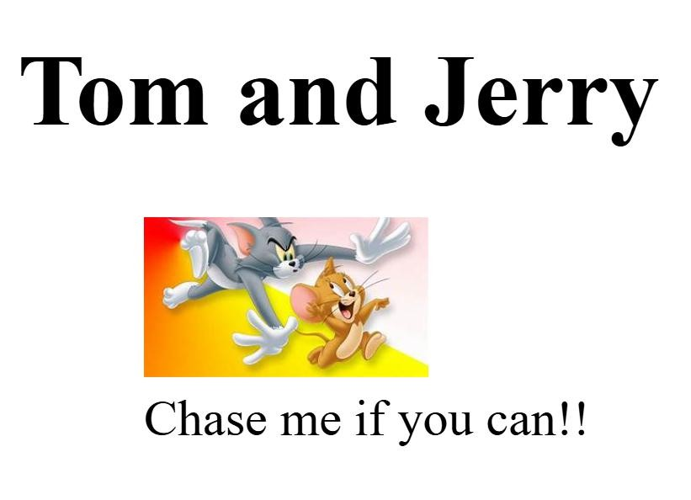

1. **Build a Navigation Menu** Create a horizontal navigation bar with links using <nav> and <ul>

<!DOCTYPE html>

<html lang="en">

<head>

<meta charset="UTF-8">

<title>Navigation Menu</title>

</head>

<body>

<nav>

<ul>

<li><a href="#home">Home</a></li>

<li><a href="#about">About</a></li>

<li><a href="#services">Services</a></li>

<li><a href="#contact">Contact</a></li>

</ul>

</nav>

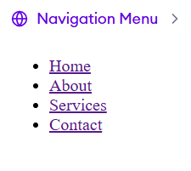

</body>

</html>

1. **Create a Contact Form** Design a simple form with text inputs, email, radio buttons, checkboxes, and a submit button.

<!DOCTYPE html>

<html lang="en">

<head>

<meta charset="UTF-8" />

<title>Contact Form</title>

</head>

<body>

<form action="#" method="post">

<label for="name">Name:</label><br>

<input type="text" id="name" name="name" placeholder="Your Name"><br><br>

<label for="email">Email:</label><br>

<input type="email" id="email" name="email" placeholder="Your Email"><br><br>

<label>Gender:</label><br>

<input type="radio" id="male" name="gender" value="male">

<label for="male">Male</label><br>

<input type="radio" id="female" name="gender" value="female">

<label for="female">Female</label><br><br>

<label>Interests:</label><br>

<input type="checkbox" id="coding" name="interest" value="coding">

<label for="coding">Coding</label><br>

<input type="submit" value="Submit">

</form>

</body>

</html>

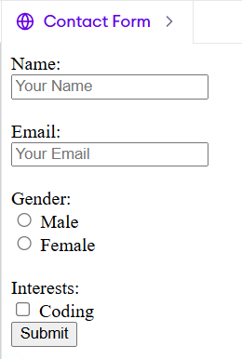

1. **Add Comments and Structure** Practice writing semantic comments and structure content into `<section>` and `<article>` tags.

<!DOCTYPE html>

<html lang="en">

<head>

<meta charset="UTF-8" />

<title>Semantic Content Structure</title>

</head>

<body>

<section id="main-content">

<article>

<h2>Introduction to Web Development</h2>

<p>Web development involves building and maintaining websites.</p>

</article>

<article>

<h2>Understanding HTML</h2>

<p>HTML is the standard markup language used to create web pages.</p>

</article>

</section>

<section id="sidebar">

<article>

<h3>Related Resources</h3>

<ul>

<li><a href="#">HTML Tutorial</a></li>

<li><a href="#">CSS Guide</a></li>

<li><a href="#">JavaScript Basics</a></li>

</ul>

</article>

</section>

</body>

</html>

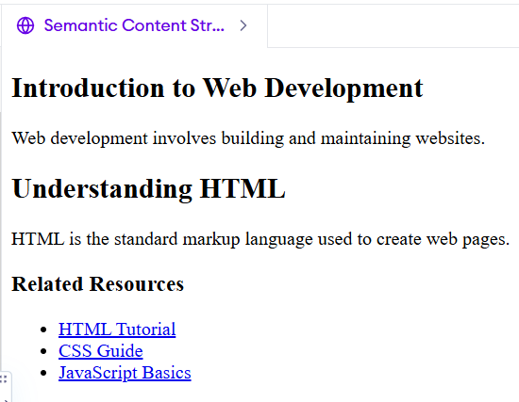

1. **Embed a YouTube Video** Add an embedded video using the `<iframe>` tag.

<!DOCTYPE html>

<html lang="en">

<head>

<meta charset="UTF-8">

<title>Embedded YouTube Video</title>

</head>

<body>

<h2>My Favorite Video</h2>

<iframe width="560" height="315" src="https[://www.youtube.com/embed/dQw4w9WgXcQ"](http://www.youtube.com/embed/dQw4w9WgXcQ) title="YouTube video player"

frameborder="0"

allow="accelerometer; autoplay; clipboard-write; encrypted-media; gyroscope; picture-in-picture"

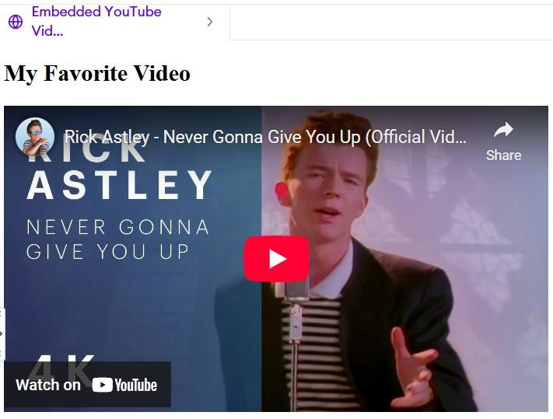

allowfullscreen>

</iframe>

</body>

</html>

1. **Use Anchor Links for Page Navigation** Create links that scroll smoothly to different sections within the page.

<!DOCTYPE html>

<html lang="en">

<head>

<meta charset="UTF-8">

<title>Anchor Link Navigation</title>

</head>

<body>

<a href="#home">Home</a> |

<a href="#about">About</a><hr>

<h2 id="home">Home Section</h2>

<p>Welcome to the homepage.</p><hr>

<h2 id="about">About Section</h2>

<p>This is the about section.</p><hr>

</body>

</html>

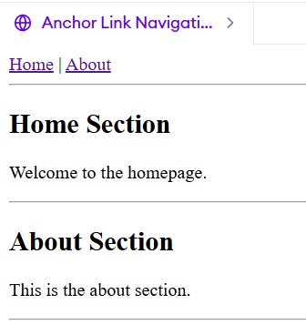

1. **Make a Table of Data** Build a table with headers, rows, and columns to display tabular information.

<!DOCTYPE html>

<html lang="en">

<head>

<meta charset="UTF-8">

<title>Student Table</title>

</head>

<body>

<h2>Student Information</h2>

<table border="1">

<thead>

<tr>

<th>Name</th>

<th>Age</th>

<th>Grade</th>

</tr>

</thead>

<tbody>

<tr>

<td>Alice</td>

<td>14</td>

<td>9th</td>

</tr>

<tr>

<td>Bob</td>

<td>15</td>

<td>10th</td>

</tr>

<tr>

<td>Charlie</td>

<td>13</td>

<td>8th</td>

</tr>

</tbody>

</table>

</body>

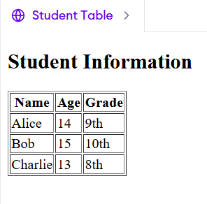

</html>

1. **Create a List of Favorite Books or Movies** Use nested ordered and unordered lists with descriptive text.

<!DOCTYPE html>

<html lang="en">

<head>

<meta charset="UTF-8">

<title>Favorites List</title>

</head>

<body>

<h2>My Favorite Books and Movies</h2>

<ol>

<li>

<strong>Books</strong>

<p>These are some books that I really enjoyed reading:</p>

<ul>

<li><em>To Kill a Mockingbird</em> by Harper Lee – A powerful story about justice and empathy.</li>

<li><em>1984</em> by George Orwell – A chilling dystopian novel about surveillance and freedom.</li>

<li><em>The Hobbit</em> by J.R.R. Tolkien – A fantasy adventure with rich world-building.</li>

</ul>

</li>

<li>

<strong>Movies</strong>

<p>Here are a few movies that I can watch over and over again:</p>

<ul>

<li><em>Inception</em> – A mind-bending thriller about dreams within dreams.</li>

<li><em>Spirited Away</em> – A beautifully animated journey through a magical world.</li>

<li><em>The Shawshank Redemption</em> – A moving story about hope and perseverance.</li>

</ul>

</li>

</ol>

</body>

</html>

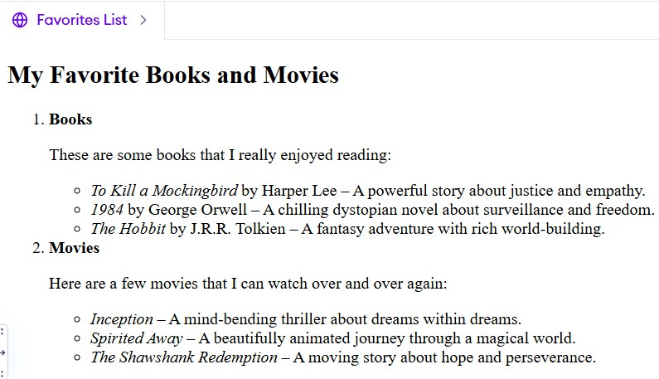

## #INTERMEDIATE SCENARIOS

1. **Responsive HTML with Meta Viewport** Build a page with responsive text elements using the meta viewport tag.

<!DOCTYPE html>

<html lang="en">

<head>

<meta charset="UTF-8">

<title>Responsive Page</title>

<meta name="viewport" content="width=device-width, initial- scale=1.0">

</head>

<body>

<h1>Welcome to My Responsive Page</h1>

<p>This page adjusts its layout based on the screen size.</p>

<h2>Why This Works</h2>

<p>

The <code>&lt;meta name="viewport"&gt;</code> tag tells the browser how to control the page's dimensions and scaling.

Without it, your content may look too small or too zoomed out on mobile devices.

</p>

<h2>Try Resizing Your Browser!</h2>

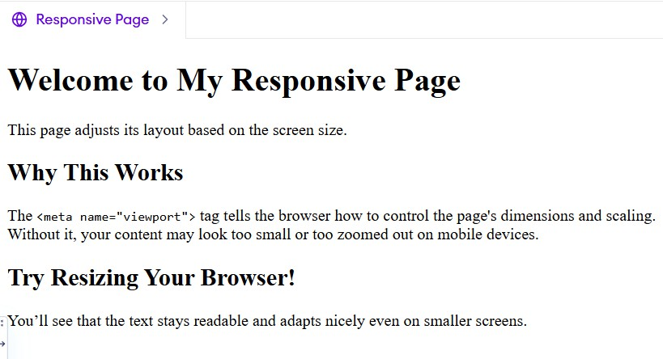

<p

You’ll see that the text stays readable and adapts nicely even on smaller screens.

</p>

</body>

</html>

1. **HTML Audio Player** Add audio controls to play music or sound files using `<audio>`.

<!DOCTYPE html>

<html lang="en">

<head>

<meta charset="UTF-8">

<title>HTML Audio Player</title>

</head>

<body>

<h2>Listen to This Audio</h2>

<audio controls>

<source src="https:/[/www.soundhelix.com/examples/mp3/SoundHelix-Song-](http://www.soundhelix.com/examples/mp3/SoundHelix-Song-)

1.mp3" type="audio/mpeg">

</audio>

</body>

</html>

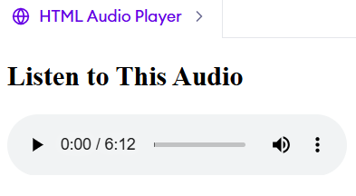

1. **Multi-page Website with Relative Links** Create two or more connected HTML pages using relative URLs in navigation.

<!doctype html>

<html lang="en">

<head>

<meta charset="utf-8">

<title>Home • Demo Site</title>

</head>

<body>

<header>

<h1>Demo Site</h1>

<nav>

<a href="./index.html">Home</a>

<a href="./about.html">About</a>

</nav>

</header>

<main>

<p>Welcome! This is the home page.</p>

</main>

<footer>&copy; 2025 Demo</footer>

</body>

</html>

<!doctype html>

<html lang="en">

<head>

<meta charset="utf-8">

<title>About • Demo Site</title>

</head>

<body>

<header>

<h1>About</h1>

<nav>

<a href="./index.html">Home</a>

<a href="./about.html">About</a>

</nav>

</header>

<main>

<p>This site demonstrates relative links between pages.</p>

</main>

<footer><a href="./index.html">Back to Home</a></footer>

</body>

</html>

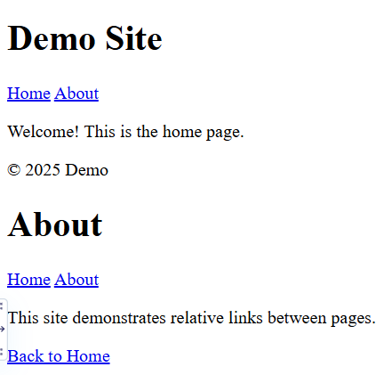

1. **Use HTML5 Semantic Elements** Design a page using

`<header>`, `<footer>`, `<main>`, `<aside>`, and `<section>` for meaningful layout.

<!DOCTYPE html>

<html lang="en">

<head>

<meta charset="UTF-8">

<title>Semantic HTML Layout</title>

</head>

<body>

<header>

<h1>My Semantic Website</h1>

<nav>

<a href="#">Home</a> |

<a href="#">About</a> |

<a href="#">Contact</a>

</nav>

</header>

<main>

<section>

<h2>Welcome</h2>

<p>This is the main content area of the site using semantic elements.</p>

</section>

<section>

<h2>Latest News</h2>

<p>Here's what's new on our website.</p>

</section>

</main>

<aside>

<h3>Related Links</h3>

<ul>

<li><a href="#">HTML5 Guide</a></li>

<li><a href="#">CSS Tricks</a></li>

<li><a href="#">Web Accessibility</a></li>

</ul>

</aside>

<footer>

<p>&copy; 2025 My Semantic Website. All rights reserved.</p>

</footer>

</body>

</html>

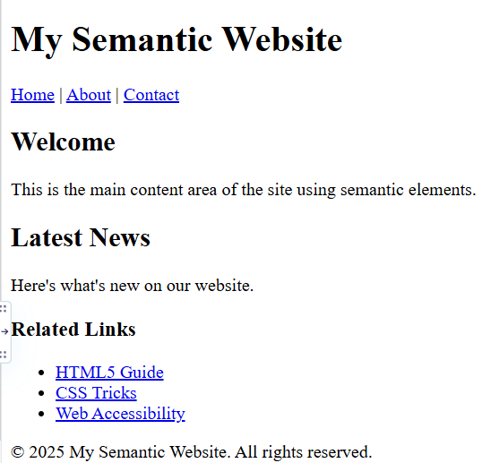

1. **Create a Blog Post Template** Design a blog post with title, date, author, content, and comment section structure.

<!DOCTYPE html>

<html lang="en">

<head>

<meta charset="UTF-8">

<title>My Blog Post</title>

</head>

<body>

<article>

<header>

<h1>How I Started Learning Web Development</h1>

<p><strong>Author:</strong> Jane Doe</p>

<p><strong>Date:</strong> September 4, 2025</p>

</header>

<section>

<p>

Learning web development has been an exciting journey. I started with HTML and CSS, then moved on to JavaScript.

Building projects helped me understand how everything fits together.

</p>

<p>

I also explored responsive design and semantic HTML to make my websites accessible and user-friendly.

</p>

</section>

<footer>

<p>Tags: <em>#HTML</em>, <em>#WebDev</em>,

<em>#Beginner</em></p>

</footer>

</article>

<hr>

<section>

<h2>Comments</h2>

<article>

<h3>Alex</h3>

<p>This is inspiring! I'm also just starting out. Thanks for sharing your experience!</p>

</article>

<article>

<h3>Maria</h3>

<p>Great tips! Looking forward to your next post.</p>

</article>

<form>

<h3>Leave a Comment</h3>

<p><input type="text" name="name" placeholder="Your Name"></p>

<p><textarea name="comment" rows="4" cols="50" placeholder="Your comment..."></textarea></p>

<p><input type="submit" value="Post Comment"></p>

</form>

</section>

</body>

</html>

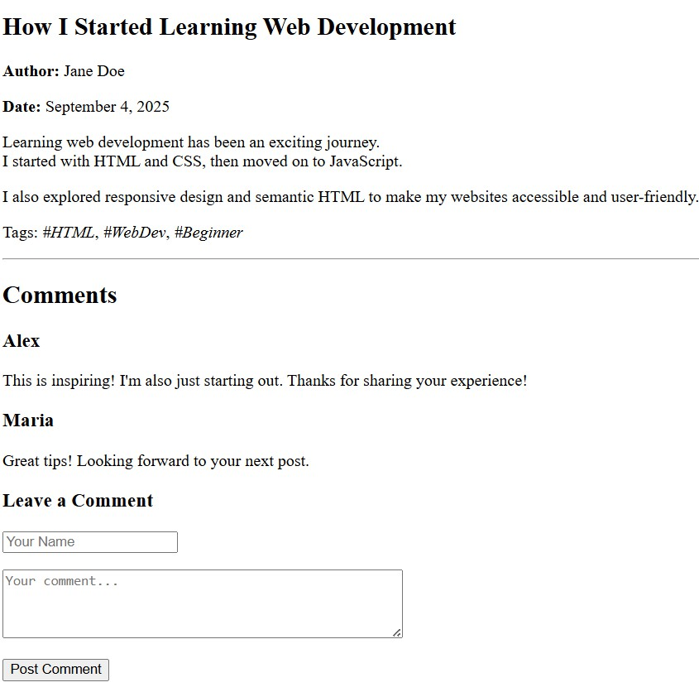

1. **Create a Pricing Table** Develop a styled pricing table with product names, features, and prices.

<!DOCTYPE html>

<html lang="en">

<head>

<meta charset="UTF-8">

<title>Airtel Prepaid Plans</title>

</head>

<body>

<h1>Airtel Prepaid Plans</h1>

<table border="1" cellpadding="10" cellspacing="0">

<thead>

<tr>

<th>Plan Name</th>

<th>Price</th>

<th>Data</th>

<th>Validity</th>

<th>Voice/SMS</th>

</tr>

</thead>

<tbody>

<tr>

<td>Prepaid ₹449</td>

<td>₹449</td>

<td>2 GB/day</td>

<td>56 Days</t> <td>—</td>

</tr>

<tr>

<td>Prepaid ₹719</td>

<td>₹719</td>

<td>1.5 GB/day</td>

<td>84 Days</td>

<td>Unlimited Calls, 100 SMS/day</td>

</tr>

<tr>

<td>Prepaid ₹3,359</td>

<td>₹3,359</td>

<td>2.5 GB/day</td>

<td>365 Days</td>

<td>Unlimited Calls, 100 SMS/day</td>

</tr>

</tbody>

</table>

</body>

</html>

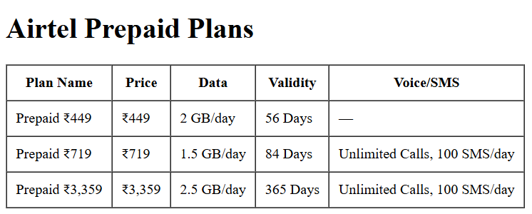

1. **Add Custom Favicon** Link a favicon icon in the `<head>` section.

<!DOCTYPE html>

<html lang="en">

<head>

<title>Favicon Example</title>

<meta charset="UTF-8">

<link rel="icon" type="image/png" href="favicon.png">

</head>

<body>

<h1>Website with Favicon</h1>

<p>Look at the browser tab — you’ll see a small icon (favicon).</p>

</body>

</html>

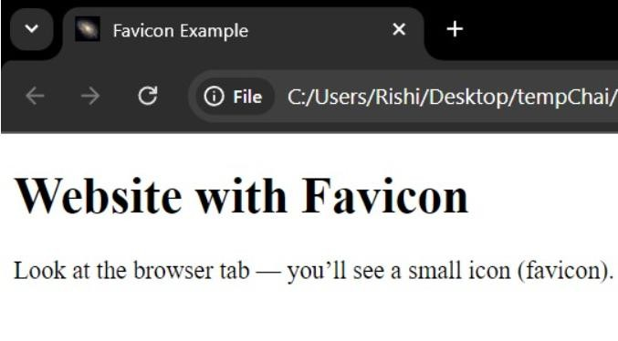

1. **Create a FAQ Page with Collapsible Sections** Use

`<details>` and `<summary>` for collapsible question-answer toggles.

<!DOCTYPE html>

<html lang="en">

<head>

<meta charset="UTF-8">

<title>FAQ Page</title>

</head>

<body>

<h1>Frequently Asked Questions</h1>

<details>

<summary>What are the hostel check-in and check-out timings?</summary>

<p>Check-in is from 8 AM to 8 PM, and check-out must be completed by 11 AM on the last day of stay.</p>

</details>

<details>

<summary>Are visitors allowed inside the hostel?</summary>

<p>Visitors are allowed only during visiting hours between 4 PM and 7 PM and must register at the security desk.</p>

</details>

<details>

<summary>Is mess food included in the hostel fees?</summary>

<p>Mess charges are separate and must be paid monthly. Vegetarian and non-vegetarian options are available.</p>

</details>

<details>

<summary>Can I bring electronic appliances like heaters or cookers?</summary>

<p>For safety reasons, use of electric cookers, heaters, and other heavy appliances inside rooms is strictly prohibited.</p>

</details>

</body>

</html>

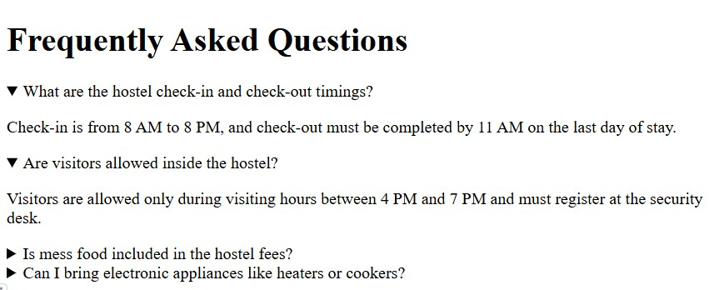

1. **Create a Product Feature List with Icons** Include icons with text using `<span>` and inline SVG or web fonts.

<!DOCTYPE html>

<html lang="en">

<head>

<meta charset="UTF-8" />

<title>Product Features</title>

</head>

<body>

<h1>Awesome Gadget Features</h1>

<ul>

<li><span>✔️</span> Long-lasting battery life (up to 24 hours)</li>

<li><span>📶</span> Fast and reliable Wi-Fi connectivity</li>

<li><span> A </span> Enhanced security features with fingerprint lock</li>

<li><span>📷</span> High-resolution dual camera system</li>

</ul>

</body>

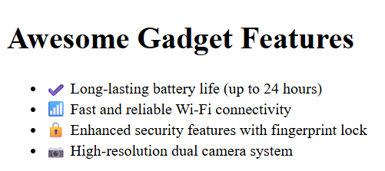

</html>

1. **Embed a Google Map** Insert an interactive map using an iframe embed from Google Maps.

<!DOCTYPE html>

<html lang="en">

<head>

<meta charset="UTF-8" />

<title>Google Map Embed - Bangalore</title>

</head>

<body>

<h1>Our Location: Bangalore</h1>

<iframe

src="https:/[/www.google.com/maps/embed?pb=!1m18!1m12!1m3!1d38](http://www.google.com/maps/embed?pb=!1m18!1m12!1m3!1d38) 88.573064973375!2d77.58064301508494!3d12.971598590847791!2m3

!1f0!2f0!3f0!3m2!1i1024!2i768!4f13.1!3m3!1m2!1s0x3bae1670a7f0f7

b9%3A0xb6518d94d815f8d6!2sBengaluru%2C%20Karnataka%205600 01%2C%20India!5e0!3m2!1sen!2sus!4v1694069587360!5m2!1sen!2su s"

width="600" height="450" style="border:0;" allowfullscreen="" loading="lazy"

referrerpolicy="no-referrer-when-downgrade" title="Google Map - Bangalore"

>

</iframe>

</body>

</html>

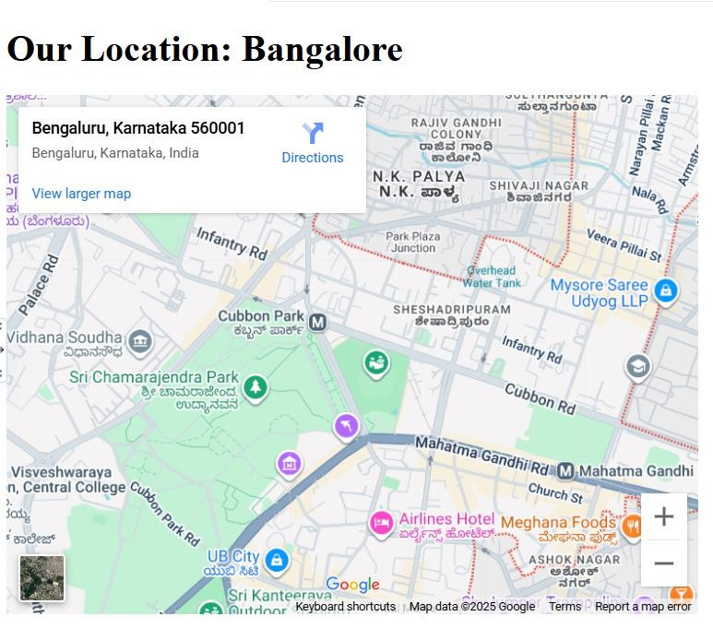

## # ADVANCED SCENARIOS

1. **HTML Email Template** Build a basic but clean email HTML structure compatible across clients.

<!DOCTYPE html>

<html>

<head>

<meta charset="UTF-8">

<title>Email</title>

</head>

<body>

<table width="100%" border="0">

<tr>

<td align="center">

<table width="600" border="1">

<tr>

<td align="center">

<h1>Welcome to Our Service</h1>

</td>

</tr>

<tr>

<td>

<p>Hello,</p>

<p>Thank you for joining us! We're glad to have you on board.</p>

<p>Here's what you get:</p>

<ul>

<li>Weekly updates</li>

<li>Special offers</li>

<li>Customer support</li>

</ul>

<p>Regards,<br>The Team</p>

</td>

</tr>

<tr>

<td align="center">

<p>You received this email because you signed up on our website.</p>

<p>123 Street, City, Country</p>

<p><a href="#">Unsubscribe</a></p>

</td>

</tr>

</table>

</td>

</tr>

</table>

</body>

</html>

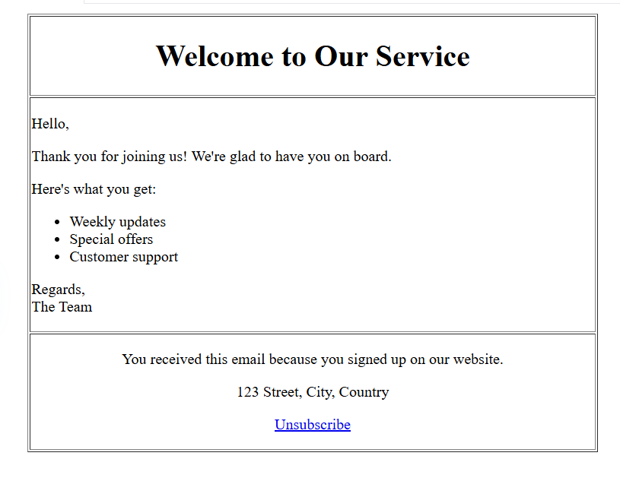

1. **Create a Landing Page with Call to Action (CTA)** Design a promotive landing page with buttons and lead capture forms.

<!DOCTYPE html>

<html lang="en">

<head>

<meta charset="UTF-8">

<title>Landing Page</title>

</head>

<body>

<h1>Join Our Newsletter</h1>

<p>Stay updated with the latest news, offers, and updates!</p>

<p>

<a href="#signup">

<button>Sign Up Now</button>

</a>

</p>

<h2 id="signup">Get Started</h2>

<form action="#" method="post">

<p>

<label for="name">Your Name:</label><br>

<input type="text" id="name" name="name" required>

</p>

<p>

<label for="email">Your Email:</label><br>

<input type="email" id="email" name="email" required>

</p>

<p>

<button type="submit">Subscribe</button>

</p>

</form>

</body>

</html>

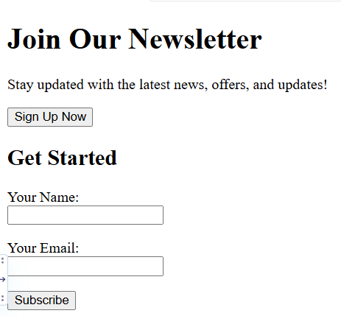

1. **Build a Responsive Grid Layout** Structure page content using CSS grid with HTML containers and elements

<!DOCTYPE html>

<html lang="en">

<head>

<meta charset="UTF-8">

<title>Responsive Grid Layout</title>

</head>

<body>

<h1 style="text-align: center;">Responsive Grid Layout</h1>

<div style=" display: grid;

grid-template-columns: repeat(auto-fit, minmax(200px, 1fr)); gap: 10px;

padding: 20px; ">

<div style="background-color: #f2f2f2; padding: 20px; text-align: center;">Box 1</div>

<div style="background-color: #e0e0e0; padding: 20px; text-align: center;">Box 2</div>

<div style="background-color: #f2f2f2; padding: 20px; text-align: center;">Box 3</div>

<div style="background-color: #e0e0e0; padding: 20px; text-align: center;">Box 4</div>

<div style="background-color: #f2f2f2; padding: 20px; text-align: center;">Box 5</div>

<div style="background-color: #e0e0e0; padding: 20px; text-align: center;">Box 6</div>

</div>

</body>

</html>

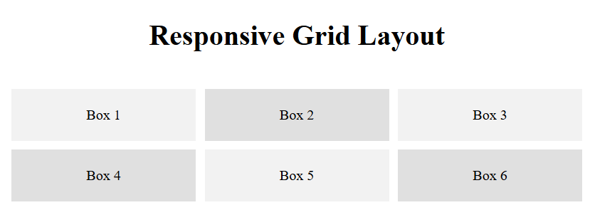

1. **Create Accessible Forms** Ensure forms use `<label>` tags properly and include ARIA roles for accessibility.

<!DOCTYPE html>

<html lang="en">

<head>

<meta charset="UTF-8">

<title>Accessible Contact Form</title>

</head>

<body>

<h1>Contact Us</h1>

<form action="#" method="post" role="form" aria- labelledby="contact-form-title">

<fieldset>

<legend id="contact-form-title">Contact Form</legend>

<p>

<label for="name">Full Name:</label><br>

<input type="text" id="name" name="name" aria-required="true" required>

</p>

<p>

<label for="email">Email Address:</label><br>

<input type="email" id="email" name="email" aria- required="true" required>

</p>

<p>

<label for="message">Your Message:</label><br>

<textarea id="message" name="message" rows="4" cols="40" aria- required="true" required></textarea>

</p>

<p>

<button type="submit" aria-label="Send Message">Submit</button>

</p>

</fieldset>

</form>

</body>

</html>

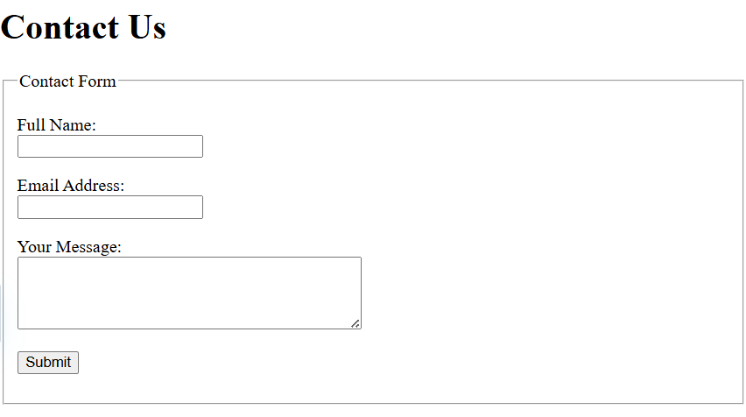

1. **Use Data Attributes for Interactivity** Add `data-*` attributes to elements for future JavaScript interaction.

<!DOCTYPE html>

<html lang="en">

<head>

<meta charset="UTF-8">

<title>Data Attributes Example</title>

</head>

<body>

<h1>Product List</h1>

<button data-product-id="101" data-product-name="Laptop" data- price="799">

Add Laptop to Cart

</button>

<button data-product-id="102" data-product-name="Smartphone" data-price="599">

Add Smartphone to Cart

</button>

<button data-product-id="103" data-product-name="Headphones" data-price="99">

Add Headphones to Cart

</button>

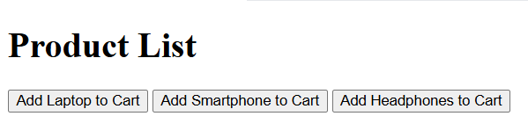

</body>

</html>

1. **Build HTML5 Canvas Integration** Set up a basic canvas element ready for drawing or animation via scripting.

<!DOCTYPE html>

<html lang="en">

<head>

<meta charset="UTF-8">

<title>HTML5 Canvas Example</title>

</head>

<body>

<h1>Canvas Integration</h1>

<canvas id="myCanvas" width="500" height="300">

</canvas>

<script>

const canvas = document.getElementById("myCanvas"); const ctx = canvas.getContext("2d");

ctx.fillStyle = "skyblue"; ctx.fillRect(50, 50, 150, 100); ctx.font = "20px Arial"; ctx.fillStyle = "black";

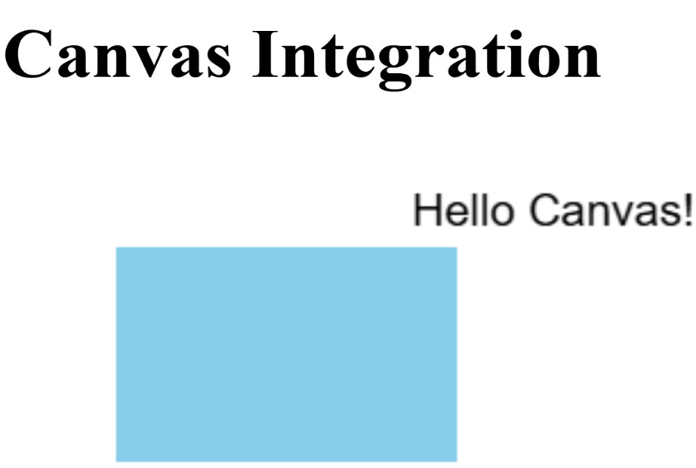

ctx.fillText("Hello Canvas!", 180, 40);

</script>

</body>

</html>

1. **Create a Media Gallery** Add a gallery of images or videos with thumbnails and detailed views.

<!doctype html>

<html lang="en">

<head>

<meta charset="utf-8">

<meta name="viewport" content="width=device-width,initial- scale=1">

<title>Simple Media Gallery</title>

</head>

<body>

<h1>Media Gallery</h1>

<p>Click on a thumbnail to view the full media (opens directly).</p>

<h2>Images</h2>

<div>

<a href="https://images.unsplash.com/photo-1501785888041- af3ef285b470?w=1600&q=80">

<img src="https://images.unsplash.com/photo-1501785888041- af3ef285b470?w=300&q=60&auto=format&fit=crop" alt="Mountain lake at sunrise" width="300">

</a>

<a href="https://images.unsplash.com/photo-1495567720989- cebdbdd97913?w=1600&q=80">

<img src="https://images.unsplash.com/photo-1495567720989- cebdbdd97913?w=300&q=60&auto=format&fit=crop" alt="Desert dunes" width="300">

</a>

<a href="https://images.unsplash.com/photo-1500530855697- b586d89ba3ee?w=1600&q=80">

<img src="https://images.unsplash.com/photo-1500530855697- b586d89ba3ee?w=300&q=60&auto=format&fit=crop" alt="City skyline at night" width="300">

</a>

</div>

<h2>Videos</h2>

<div>

<video controls width="320">

<source src="https://interactive- examples.mdn.mozilla.net/media/cc0-videos/flower.mp4" type="video/mp4">

Your browser does not support the video tag.

</video>

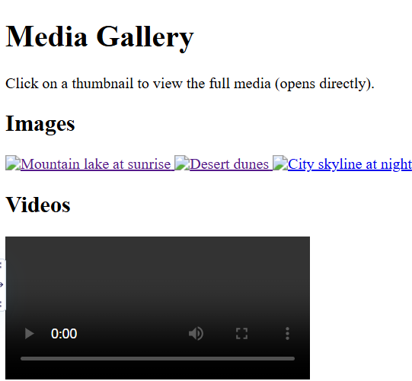

</div>

</body>

</html>

1. **Integrate Microdata or Schema.org Markup** Annotate content with semantic tags for SEO and rich search results.

<!DOCTYPE html>

<html lang="en">

<head>

<meta charset="UTF-8">

<title>Local Business with Schema.org Microdata</title>

</head>

<body>

<div itemscope itemtype="https://schema.org/LocalBusiness">

<h1 itemprop="name">Fresh Brew Café</h1>

<p><strong>Address:</strong>

<span itemprop="address" itemscope itemtype="https://schema.org/PostalAddress">

<span itemprop="streetAddress">123 Brew Street</span>,

<span itemprop="addressLocality">Bangalore</span>,

<span itemprop="addressRegion">KA</span> -

<span itemprop="postalCode">560001</span>

</span>

</p>

<p><strong>Phone:</strong> <span itemprop="telephone">+91- 9876543210</span></p>

<p><strong>Website:</strong>

<a href="https[://www.freshbrewcafe.com"](http://www.freshbrewcafe.com/) itemprop="url[">www.freshbrewcafe.com</a>](http://www.freshbrewcafe.com/)

</p>

<p><strong>Opening Hours:</strong>

<span itemprop="openingHours" content="Mo-Sa 08:00- 20:00">Mon–Sat: 8 AM – 8 PM</span>

</p>

<p><strong>Rating:</strong>

<span itemprop="aggregateRating" itemscope itemtype="https://schema.org/AggregateRating">

<span itemprop="ratingValue">4.6</span> stars from

<span itemprop="reviewCount">112</span> reviews

</span>

</p>

</div>

</body>

</html>

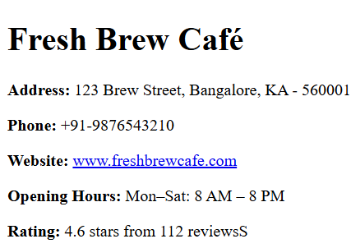

1. **Create a Dynamic Table with Sortable Columns** Use

`table` elements and prepare for JavaScript sorting functionality.

<!DOCTYPE html>

<html lang="en">

<head>

<meta charset="UTF-8">

<title>Sortable Table with JavaScript</title>

</head>

<body>

<h1>Student Grades</h1>

<table id="studentTable" border="1">

<thead>

<tr>

<th data-type="string">Name</th>

<th data-type="string">Subject</th>

<th data-type="number">Grade</th>

</tr>

</thead>

<tbody>

<tr>

<td>Alice</td>

<td>Math</td>

<td>88</td>

</tr>

<tr>

<td>Bob</td>

<td>Science</td>

<td>91</td>

</tr>

<tr>

<td>Charlie</td>

<td>English</td>

<td>84</td>

</tr>

<tr>

<td>Diana</td>

<td>History</td>

<td>95</td>

</tr>

</tbody>

</table>

<script>

const table = document.getElementById('studentTable'); const headers = table.querySelectorAll('th');

let sortDirections = Array(headers.length).fill(1); headers.forEach((header, columnIndex) => { header.addEventListener('click', () => {

const type = header.getAttribute('data-type');

const rows = Array.from(table.querySelectorAll('tbody tr')); rows.sort((a, b) => {

const aText = a.children[columnIndex].textContent.trim(); const bText = b.children[columnIndex].textContent.trim(); if (type === 'number') {

return sortDirections[columnIndex] * (parseFloat(aText) - parseFloat(bText));

} else {

return sortDirections[columnIndex] * aText.localeCompare(bText);

}

});

sortDirections[columnIndex] *= -1; const tbody = table.querySelector('tbody'); tbody.innerHTML = '';

rows.forEach(row => tbody.appendChild(row));

});

});

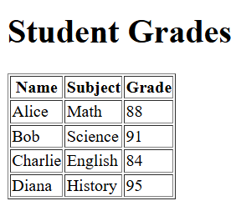

</script>

</body>

</html>

1. **Develop a Multi-language Page Template** Structure your page to support multiple languages with `lang` attributes and alternate links.

<!DOCTYPE html>

<html lang="en">

<head>

<meta charset="UTF-8">

<title>Welcome Page</title>

<link rel="alternate" hreflang="en" href="https://example.com/en.html">

<link rel="alternate" hreflang="fr" href="https://example.com/fr.html">

<link rel="alternate" hreflang="es" href="https://example.com/es.html">

</head>

<body>

<nav>

<p>

<a href="en.html" lang="en">English</a> |

<a href="fr.html" lang="fr">Français</a> |

<a href="es.html" lang="es">Español</a>

</p>

</nav>

<section lang="en">

<h1>Welcome to Our Website</h1>

<p>Thank you for visiting. We hope you find what you're looking for.</p>

</section>

<section lang="fr">

<h1>Bienvenue sur notre site web</h1>

<p>Merci de votre visite. Nous espérons que vous trouverez ce que vous cherchez.</p>

</section>

<section lang="es">

<h1>Bienvenido a nuestro sitio web</h1>

<p>Gracias por visitarnos. Esperamos que encuentre lo que busca.</p>

</section>

</body>

</html>

